13th Annual Holy Spokes Bicycle Tour
Registration Form
Saturday, May 24, 2025, at 9:30 AM
(Registration begins at 8:30)
120 West Dwight Street
Oscoda, Michigan

Name ________________________________________ Gender ______________

Street Address ______________________________________________________

City, State ___________________________________ Zip ____________________

Phone ___________________________________Year of Birth _______________

E-mail ___________________________________ Route (9, 20, 50) ____________

* Check desired unisex t-shirt size

Small ______ Medium ________

Large _______ X-Large_________

XX-Large __________

Day of Registration Fee: $25.00/cyclist
Pre-register Fee: $20.00/cyclist
T-Shirts: $25.00*

Total Amount: $ _____________ (No Refunds)

Make checks payable to: OUMC Youth

(T-shirt order must be received by May 10, 2025)

All children under the age of 16 years must be accompanied by an adult.

Release Agreement: I, ____________________________________, freely acknowledge and

realize the dangers in participating in the Holy Spokes Bicycle Tour and fully assume all risks,
including, but not limited to, the course.

Signature __________________________________________ Date ____________
If under 18, Signature of Parent/Guardian __________________________________________

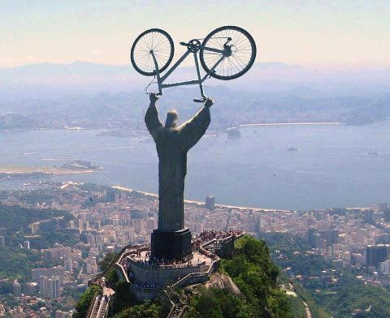
13th Annual Holy Spokes Bicycle Tour 2025

Saturday, May 24, 2025 at 9:30 AM
Oscoda, Michigan

The Oscoda United Methodist Church Youth embark each year in June on a summer mission trip to various locations around the country. Several local young people work hard helping the elderly, the needy, and communities. To help fund this incredible cause, we have created the “Holy Spokes Bicycle Tour”. This isn’t a race; it is a ride! We boast the beautiful Huron National Forest and the Au Sable River as the backdrop for our event geared toward outdoor enthusiasts. The bike ride will begin and end at the Oscoda United Methodist Church (OUMC) located in downtown Oscoda, on the shores of Lake Huron. There will be three rides from which to choose: a challenging 50-mile ride option, a moderate 20-mile ride option and a 9-mile fun ride! There will be pizza and refreshments available at OUMC for the riders upon completion. There will also be water and snack stops along the routes. Morning registration begins at 8:30 AM. Preregistration is preferred, but same-day registrations will be accepted. T-shirts must be preordered. To order a T-shirt, registration and payment must be submitted by May 10, 2025.

If you would like to sponsor, please contact Jeff Senn at 989-305-1375.

